Right outer Join

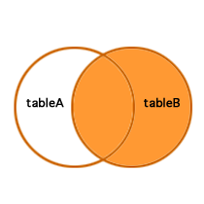

Left Outer Join

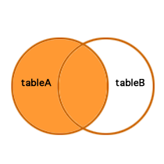

Inner Join

[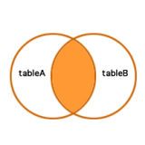](http://mysqljoin.com/wp-content/uploads/2010/12/inner_join1.png)

Cross Join